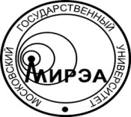
MINISTRY OF EDUCATION AND SCIENCE
OF RUSSIAN FEDERATION

Federal State Budget

Educational Institution of Higher Education

«Moscow Technological University»

MITHT
Vernadskogo Аv., 86, Moscow, 119571, Russia
phone: +7 (495) 246 05 55, fax: +7 (499) 600 83 00
е-mail: mirea@mirea.ru, http://www.mirea.ru
__________________ № _________________
on № _____________ of _________________

Образец углового бланка МИТХТ на английском языке

