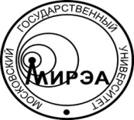
MINISTRY OF EDUCATION AND SCIENCE
OF RUSSIAN FEDERATION

Federal State Budget

Educational Institution of Higher Education

«Moscow Technological University»

MIREA
Vernadskogo Аv., 78, Moscow 119454, Russia
phone: + 7 (499) 215 65 65 ext. 1140, fax: +7 (495) 434 92 87
e-mail: mirea@mirea.ru, http://www.mirea.ru
__________________ № _________________
on № _____________ of ________________

Federal State Budget Educational Institution of Higher Education «Moscow Technological University».

Образец углового бланка МИРЭА на английском языке

