- Introduction.
Microfabrication of microlens arrays is using common steps and operations that are similar to semiconductor producing. That steps are photolithography and resist processing (reflow) and reactive ion etching (RIE) for microlens transferring is fused silica or silicon.
We summarize the basic physical and optical properties of plano-convex refractive microlens arrays.
- Overview of plano-convex microlens arrays
A plano-convex microlens is described by the lens diameter Ø, the height at the vertex hL, the radius of curvature R, the refractive index n and the contact angle α as shown in figure 1(a). Figure 1(b) shows a scheme of a rectangular (left) and a hexagonal packed lens array (right).
  - Radius of curvature and focal length The lens profile h(r) of an axial symmetrical plano-convex lens is generally described by

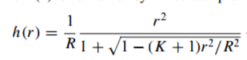
(1)

where h is the height of the lens as a function of the distance r to the optical axis, R is the radius of curvature at the vertex and K is the aspherical constant. The lens profile

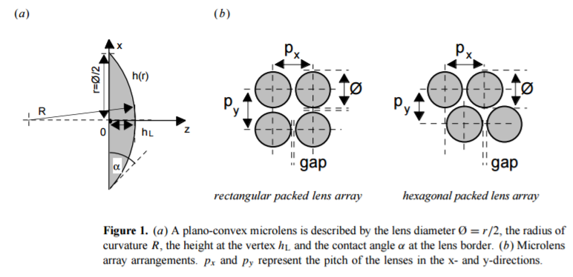
h(r) might be spherical (K = 0), elliptic (−1 <K< 0 or K > 0), parabolic (K = −1), hyperbolic (K < −1) or even more sophisticated. The radius of curvature at the vertex is given by
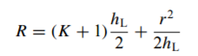
(2)

where hL is the height at the vertex. The vertex focal length f of a plano-convex refractive lens is given by

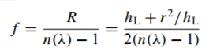
(3)

where n is the refractive index and λ the wavelength. The focal length f is a function of the wavelength λ due to material dispersion. The contact angle α at the border of a spherical plano-convex lens (K = 0) is given by

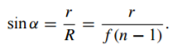
(4)

The Seidel coefficient for spherical aberration of a thin spherical lens (K = 0) is given by
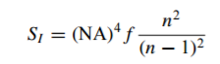
(5)

where NA is the numerical aperture [1]. A plano-convex hyperboloid (K = −n2) has no spherical aberration for a plane wave (perpendicular incidence, planar side versus incident rays) [2]. The F-number of a lens (lens diameter Ø = 2r) is given by

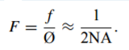
(6)

The diffraction-limited resolution δx and the depth of focus δz are given by

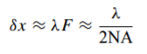
(7)

and

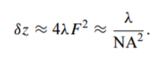
(8)

Both δx and δz are independent of the lens scale. A downscaling of all length parameters does not affect the diffraction-limited resolution of a lens. However, a scaling changes the magnitude of wavefront aberrations which are expressed in fractions of the wavelength. Small lenses have smaller aberrations than large lenses (for the same F-number and wavelength) [3].

- Production of microles arrays
  - Positive photoresist is coated on top of the base layer using a SUSS RC 8 spin coater. A uniformity on the order of ±2% is achieved for thick resist layers. After a prebake at 80–90 ◦C (typically 1 h), a chromium-on-glass mask is contact copied in a mask aligner. The exposed resist is resolved in a standard developing process. An array of photoresist cylinders is obtained. The resist cylinders are melted at a temperature of 150–200 ◦C on a hot plate or in an oven. The melting procedure itself is quite simple to perform. A melted-resist structure will always act like a microlens.
  - The next step was RIE transfer in silicon is applied for microlenses used in the IR wavelength region. RIE process was done in the CCP-type chamber.
Finally Microlens arrays with 120um in and 125um pitch were produced on silicon wafers figure (3).

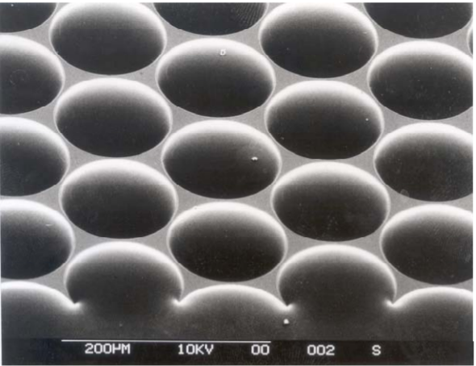

Figure 3.

- Anti-reflecting coating.
Anti-reflecting (AR) coating has strong impact on performance of microlens arrays. The Ta₂O₅ layer was applied to get wavelength between 1250 - 1650 nm. We deposited a thin film of d = 110 nm Ta2O5, with a close to ideal refractive index of nTa2O5 = 2.1 at 930 nm, onto the samples. We confirm the deposition of a homogeneous layer of Ta2O5 even on the curved surface of the microlens by scanning electron microscopy (SEM-) images (not shown here).

- Microlens array application.
Microlens arrays are widely used in optical computing and neural networks. Typical tasks are in the collimating of light sources, e.g. a surface emitting laser array. Microlens arrays could be used as fan-in elements.

