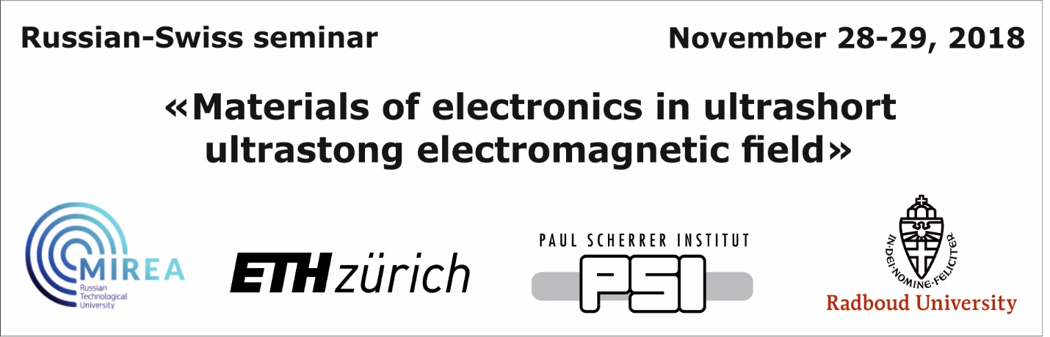

Preliminary program
November 28, Wednesday

10:00-10:20 | Academician of RAS Alexander Sigov  President RTU MIREA;  Mr. Andrey Melnikov  State Secretariat for Education Embassy of Switzerland in Russia  Opening ceremony
10:20-11:05 | Prof. Dr. Steve Johnson  ETH Zurich (Swiss Federal Institute of Technology)  “The Ultrafast Einstein-de Haas Effect”
11:05-11:30 | Prof. Elena Mishina  RTU MIREA  “Ultrafast Physics in RTU MIREA”
11:30-12:00 | Coffee break & Posters
12:00-12:45 | Dr. Roman Mankowsky  Paul Scherrer Institut  “Ultrafast control of the ferroelectric polarization”
12:45-13:30 | Prof. A.K. Zvezdin  Prokhorov General Physics Institute RAS, Moscow  “Mechanisms of ultrafast all-optical switching in cubic ferromagnets”
13:30-14:15 | Lunch
November 29, Thursday
12:00-12:45 | Prof. Alexey Kimel  Radboud University Nijmegen, The Netherlands  “Magnetic writing with light flashes”
12:45-13:15 | Dr. Nataliya Sherstyuk  RTU MIREA  “Optical rectification in fs and THz regime”
13:15-14:00 | Coffee break & Posters
14:00-15:00 | Dr. Alexandra Kalashnikova  The Ioffe Physical-Technical Institute of the Russian Academy of Sciences, Saint-Petersburg  “Ultrafast insulator-to-metal transition in VO2 nanostructures assisted by picosecond strain pulses”
15:00-15:30 | Mikhail Kozhaev  Prokhorov General Physics Institute RAS, Moscow  “Ultrafast spin dynamics and Inverse Spin Hall Effect in magnetic nanostructures”
15:30-16:00 | TBA  The Ioffe Physical-Technical Institute of the Russian Academy of Sciences, Russia.  “Spin wave generation”
16:00-16:15 | Alexander Tkachev  Director of the Center for Innovative Technology and Engineering Russian Technological University, Russia.  “Presentation of Eureka Program”

